Daniel Goldstein

2425 E Northern Pkwy Fl 1

Baltimore, MD 21214-1140

(410) 491-3662 [dmgoldstein1@gmail.com](mailto:dmgoldstein1@gmail.com)

**Invoice #0021 for Services Rendered**

Wednesday, August 14, 2024

Dr. Carla Sandy

Sandy Audio Visual LLC

14625 Baltimore Ave #901

Laurel, MD 20707

(202) 494-4777

invoice@savweb.com

cc:

Colin Sandy

csandy@savweb.com

Andrea Jefferson

[andrea@savweb.com](mailto:andrea@savweb.com)

Kaywon Smith

ksmith@savweb.com

Hello Dr. Sandy,

Attached you will find an invoice for my work at The Columbia Association on Thursday, April 11, 2024, Thursday, May 23, 2024 and Thursday, July 25, 2024, as well as my work on the Maryland School for the Deaf Graduation from Wednesday, May 29, 2024 to Friday, May 31, 2024. Please let me know if there is anything else I can do. I can be paid via ACH as you have done in the past.

Thank you very much. It was a pleasure to work for your client and I look forward to the next opportunity to do so. Also, please feel free to share any constructive criticism you received regarding my performance.

Sincerely,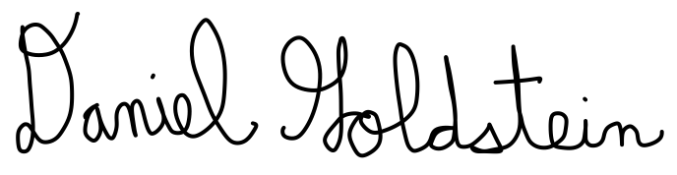

Daniel Goldstein

Audiovisual Professional

Attached:

Invoice #0021

Daniel Goldstein

2425 E Northern Pkwy Fl 1

Baltimore, MD 21214-1140

|  |  |  |  |  |  |
| --- | --- | --- | --- | --- | --- |
| **Date** | **Job Description** | **Time(s)** | **Hours** | **Hourly Rate** | **Amount Billed** |
| Thursday, April 11, 2024 | The Columbia Association | 6pm to 10pm | 4 | $50 | $200.00 |
| Thursday, May 23, 2024 | The Columbia Association | 6pm to 8:45pm | 2.75 | $50 | $137.50 |
| Wednesday, May 29, 2024 | Maryland School for the Deaf | 10am to 3pm | 5 | $50 | $250.00 |
| Thursday, May 30, 2024 | Maryland School for the Deaf | 12pm to 5pm | 5 | $50 | $250.00 |
| Friday, May 31, 2024 | Maryland School for the Deaf | 7am to 2:30pm | 7.5 | $50 | $375.00 |
| Thursday, July 25, 2024 | The Columbia Association | 6pm to 9:30pm | 3.5 | $50 | $175.00 |
| **Total:** | | | | | $1387.50 |

(410) 491-3662 [dmgoldstein1@gmail.com](mailto:dmgoldstein1@gmail.com)

**Invoice #0021**